Tolfenamic Acid

(Last updated 13 March 2023)

Figure . The molecular diagram of Tolfenamic Acid.

# CSP studies

Ogaga Uzoh did a limited search on tolfenamic acid as part of his work on whether the fenamate group was a polymorphophore. Unfortunately, this was too limited to find many experimentally observed crystal structures, and so it was repeated by Louise at a later date.

|  |  |
| --- | --- |
| REFCODE | KAXXAI |
| Formula | C14 H12 Cl1 N1 O2 |
| Common Name | Tolfenamic Acid |
| IUPAC Systematic Name | 2-((3-Chloro-2-methylphenyl)amino)benzoic acid |
| Other Names | N-(2-Methyl-3-chlorophenyl)anthranilic acid |
| CSD Refcodes | KAXXAI, KAXXAI01, KAXXAI02, KAXXAI03, KAXXAI04, KAXXAI05, KAXXAI06, KAXXAI07, KAXXAI11 |
|  |  |
| Search Identifier | A |
| Scientist | Ogaga Uzoh |
| Date | 2011 |
| Publication | Uzoh OG, Cruz-Cabeza AJ, Price SL 2012. Cryst Growth Des 12, 4230-4239. |
| Energy Model | 1 |
| Study_ID | 10 |
| Programs | CrystalPredictor (1.8), CrystalOptimizer (2.1), DMACRYS (2.0.4) |
| Location on S Drive | /CHEMISTRY_CPOSS/Fenamates/TolfenamicAcid/KAXXAI_CO |
| Potential Description | CrystalOptimizer PBE1PBE/6-31+G(d) intramolecular energy with PBE1PBE/6-31+G(d) charge density and FIT potential |
| Energy Model | 2 |
| Study_ID | 30 (published) |
| Programs | Study_ID=10, DMACRYS (2.0.4) |
| Location on S Drive | /CHEMISTRY_CPOSS/Fenamates/TolfenamicAcid/KAXXAI_PCM |
| Potential Description | GDMA2.2(PCMdielectric3(PBE1PBE/6-31+G(d))) + FIT |
|  |  |
| Search Identifier | B |
| Scientist | Louise Price |
| Date | 2016 |
| Publication | Case, D. H.; Srirambhatla, V. K.; Guo, R.; Watson, R. E.; Price, L. S.; Polyzois, H.; Cockcroft, J. K.; Florence, A. J.; Tocher, D. A.; Price, S. L., Successful Computationally Directed Templating of Metastable Pharmaceutical Polymorphs. Crystal Growth & Design 2018, 18, (9), 5322-5331. |
| Energy Model | 1 |
| Study_ID | 21 |
| Programs | CrystalPredictor (1.8), dmaflex-Quick, DMACRYS (2.2.0.1) |
| Location on S Drive | /CHEMISTRY_CPOSS/Fenamates/TolfenamicAcid/KAXXAI_CP |
| Potential Description | CrystalPredictor + DMAflex-Quick, rotated charge densities from B3LYP/6-31G(d,p) + FIT |
| Energy Model | 2 |
| Study_ID | 11 |
| Programs | Study_ID=21, CrystalOptimizer (2.4.m), DMACRYS (2.2.0.1) |
| Location on S Drive | /CHEMISTRY_CPOSS/Fenamates/TolfenamicAcid/KAXXAI_CO2 |
| Potential Description | CrystalOptimizer PBE1PBE/6-31+G(d) intramolecular energy with PBE1PBE/6-31+G(d) charge density and FIT potential |
| Energy Model | 3 |
| Study_ID | 31 (published) |
| Programs | Study_ID=11, DMACRYS (2.2.0.1) |
| Location on S Drive | /CHEMISTRY_CPOSS/Fenamates/TolfenamicAcid/KAXXAI_PCM2 |
| Potential Description | GDMA2.2(PCMdielectric3(PBE1PBE/6-31+G(d))) + FIT |
| Energy Model | 4 |
| Date | 2024 |
| Publication | Database updating paper |
| Study_ID | 12 (includes pDFT-D) |
| Programs | Study_ID=11, CrystalOptimizer (2.4.7), DMACRYS (2.3.1.1) |
| Location on S Drive | /CHEMISTRY_CPOSS/Fenamates/TolfenamicAcid/KAXXAI_DFT |
| Potential Description | CrystalOptimizer PBE1PBE/6-31+G(d) intramolecular energy with PBE1PBE/6-31+G(d) charge density and FIT potential |

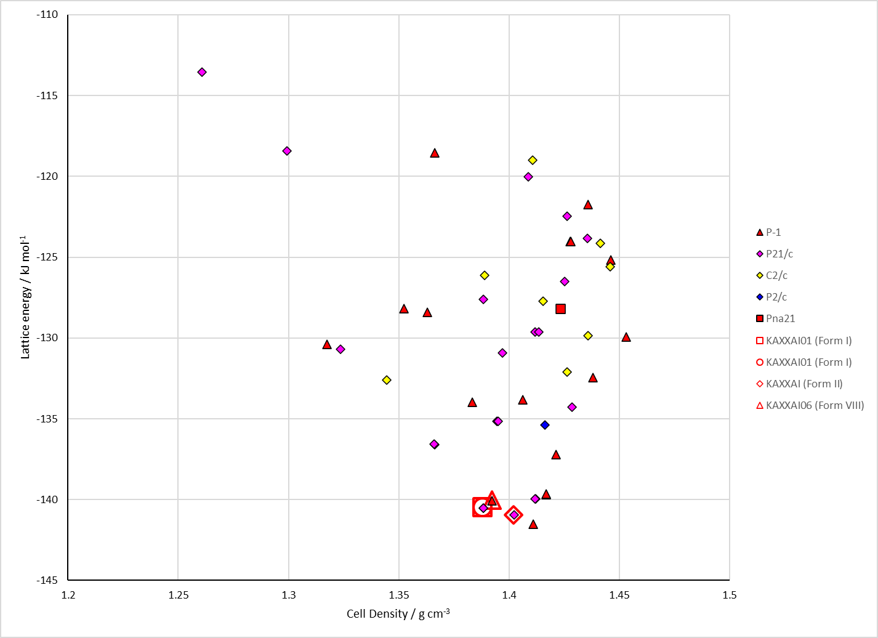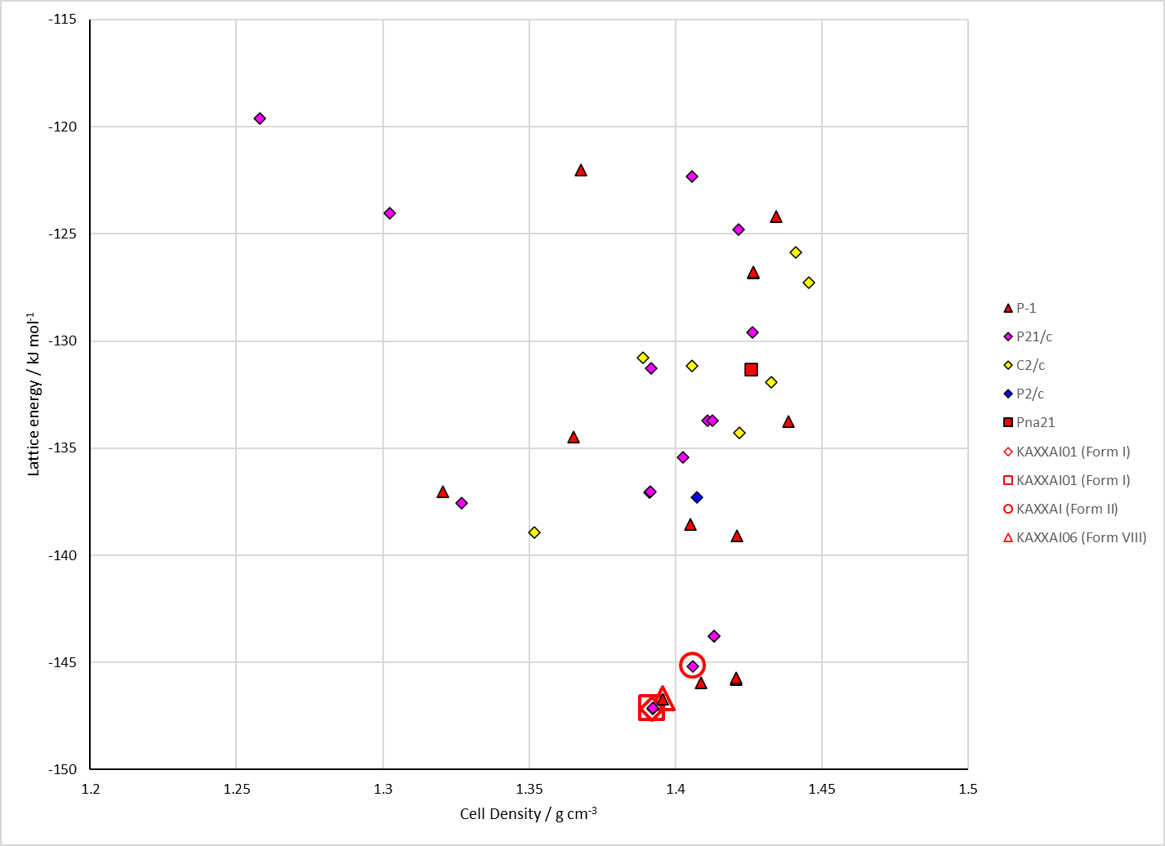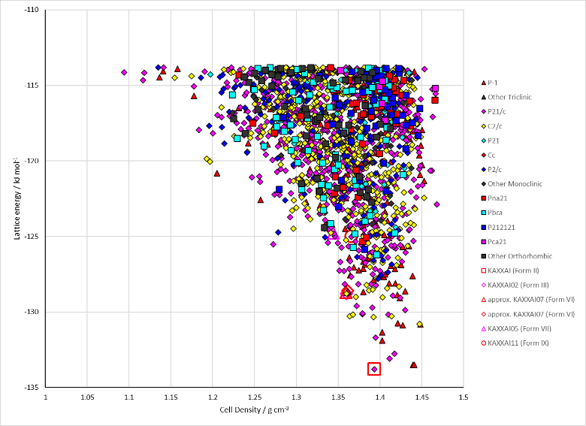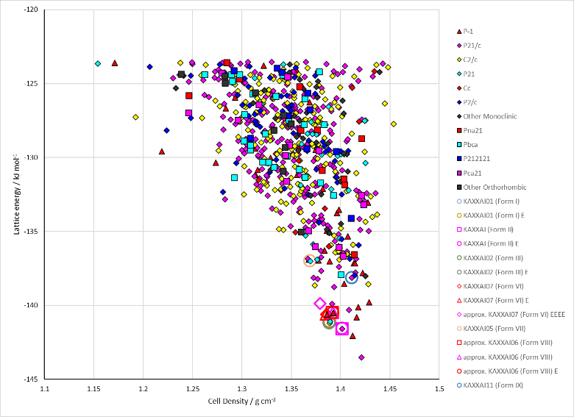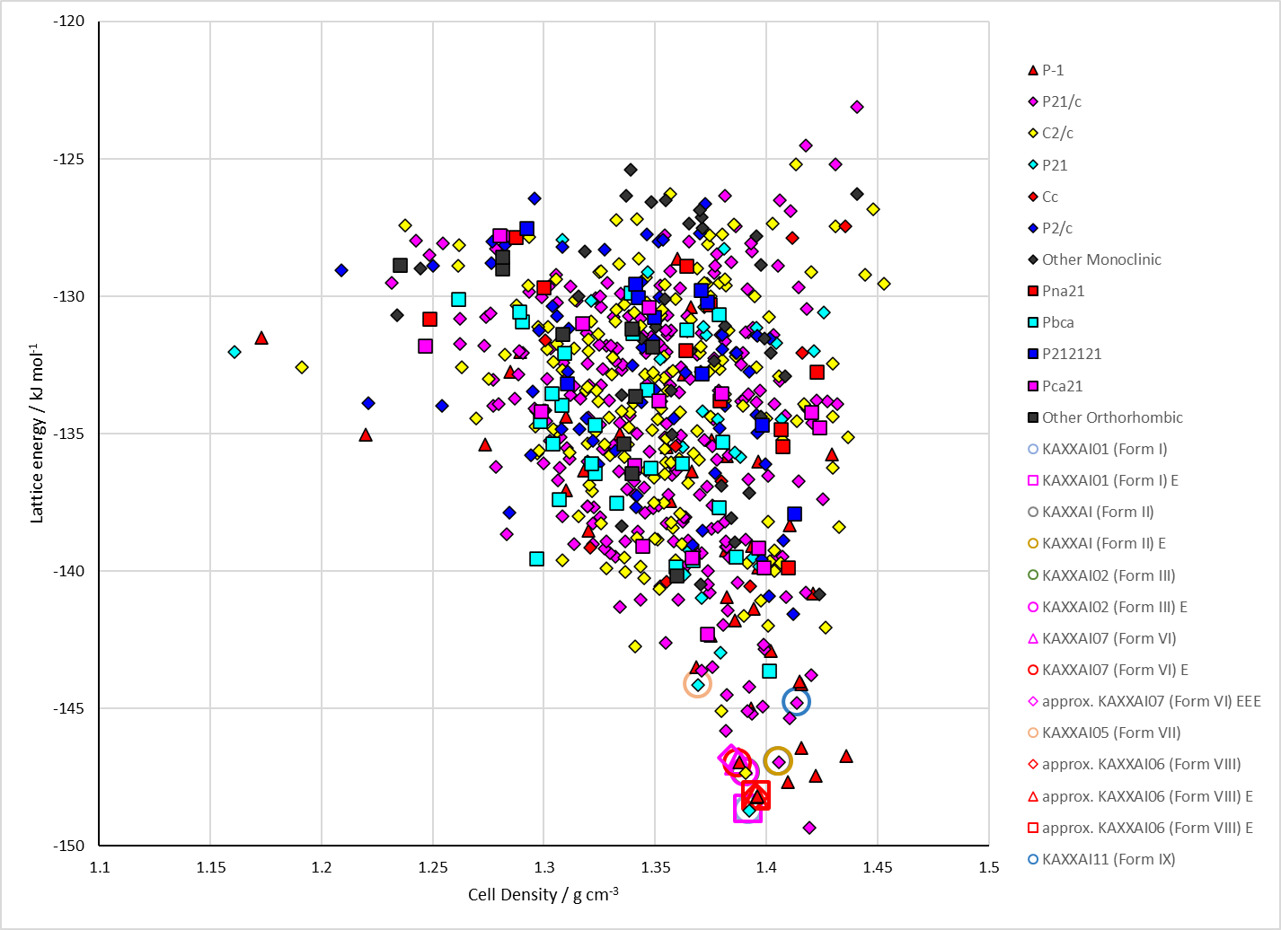

Figure . Crystal energy landscapes of Tolfenamic Acid from previous work. (Top) the original work by Ogaga Uzoh with (left) CrystalOptimizer refinement and (right) PCM refinement. (Middle, bottom) the repeated work by Louise Price with (middle left) the CrystalPredictor search, (middle right) CrystalOptimizer refinement and (bottom) PCM refinement.

# CSD structures (CSD version 5.43 with Mar, Jun, Sep and Nov 2022 updates)

Table . Crystallographic information for CSD entries for Tolfenamic Acid. Different polymorphs are coloured differently.

|  |  |  |  |  |  |  |  |  |  |  |
| --- | --- | --- | --- | --- | --- | --- | --- | --- | --- | --- |
| REFCODE | space group | Z’ | a / Å | b / Å | c / Å | α / ° | β / ° | γ / ° | density / g cm-3 | Form |
| KAXXAI | P21/n | 1 | 3.836 | 21.997 | 14.205 | 90 | 94.11 | 90 | 1.454 | yellow II |
| KAXXAI01 | P21/c | 1 | 4.826 | 32.128 | 8.041 | 90 | 104.88 | 90 | 1.443 | white I |
| KAXXAI02 | P21/c | 2 | 7.6356 | 11.305 | 28.065 | 90 | 93.03 | 90 | 1.437 | III |
| KAXXAI03 | P-1 | 3 | 7.5237 | 14.3308 | 17.592 | 103.68 | 98.253 | 93.038 | 1.435 | IV |
| KAXXAI04 | P-1 | 1 | 7.6488 | 9.016 | 9.4184 | 107.385 | 92.062 | 101.662 | 1.439 | V |
| KAXXAI05 | P21/n | 1 | 6.748 | 29.153 | 7.1 | 90 | 112.829 | 90 | 1.35 | VII |
| KAXXAI06 | P-1 | 1 | 8.0025 | 16.4742 | 4.8422 | 95.735 | 105.222 | 94.752 | 1.427 | VIII |
| KAXXAI07 | P-1 | 1 | 6.7482 | 7.2034 | 14.3406 | 77.497 | 78.947 | 65.963 | 1.408 | VI |
| KAXXAI08 | P-1 | 1 | 6.7049 | 7.2778 | 14.163 | 77.167 | 79.908 | 65.487 | 1.424 | VI |
| KAXXAI09 | P21/c | 1 | 4.8283 | 32.0832 | 8.0221 | 90 | 104.936 | 90 | 1.448 | I |
| KAXXAI10 | P21/n | 1 | 3.84618 | 21.9502 | 14.1764 | 90 | 94.235 | 90 | 1.456 | II |
| KAXXAI11 | P21/c | 1 | 10.5841 | 7.8503 | 14.9718 | 90 | 101.399 | 90 | 1.425 | IX |

Table . Experimental information for CSD entries for Tolfenamic Acid.

|  |  |  |  |  |  |
| --- | --- | --- | --- | --- | --- |
| REFCODE | space group | R factor | T / K | Year | Comments |
| KAXXAI | P21/n | 2.9 | 110 | 1989 | Rapid cooling of a boiling 96% ethanol solution using an ice bath1 |
| KAXXAI01 | P21/c | 5.2 | 110 | 1989 | Recrystallization from absolute ethanol1 |
| KAXXAI02 | P21/c | 4.48 | 85 | 2009 | Grown from an ethanol solution using nonpolar aromatic polymers as heteronuclei2 |
| KAXXAI03 | P-1 | 7.23 | 85 | 2009 | Grown from an ethanol solution using nonpolar aromatic polymers as heteronuclei2 |
| KAXXAI04 | P-1 | 6.58 | 85 | 2009 | Grown from an ethanol solution using nonpolar aromatic polymers as heteronuclei2 |
| KAXXAI05 | P21/n | 7.04 | 293 | 2018 | Sublimation onto tolfenamic/flufenamic acid solid solution.3 |
| KAXXAI06 | P-1 | 16.1 | 120 | 2018 | Sublimation onto a metal surface.3 |
| KAXXAI07 | P-1 | 5.03 | 151 | 2018 | Sublimation onto isomorphous mefenamic acid form I.3 |
| KAXXAI08 | P-1 | 7.92 | 100 | 2020 | 50 mg of TFA was dissolved in 10 ml of acetone:methanol (1:1) solvent mixture at 50 to 55°C to produce clear solution which was then allowed to cool without stirring. After cooling to 30°C, a couple of single crystals of MFA form I were added to the solution. Upon evaporation of the solvent, crystals of TFA form VI were obtained.4 |
| KAXXAI09 | P21/c | 6.41 | 100 | 2020 | Slow evaporation at room temperature from ethyl acetate.5 |
| KAXXAI10 | P21/n | 4.56 | 150 | 2020 | Attempted salt crystallization experiment. A 1:1 molar ratio of tolfenamic acid and N-(2-hydroxyethyl)pyrrolidine were dissolved in ethyl acetate. This was left to slowly evaporate giving yellow needle crystals of pure form II.5 |
| KAXXAI11 | P21/c | 5.77 | 293 | 2021 | A suspension of tolfenamic acid form I in 2-propanol was heated to 50°C. After dissolution and filtering into a crystallizing dish, the dish was covered with parafilm and put in a fridge at 5°C. After two hours a few blocky crystals of form IX were discovered concomitantly with forms I and II.6 |

# Other notes

REFCODES for solid solutions are SIMDOK (60TFA:04FFA), SIMDOK01 (53TFA:47FFA), SIMFUS (25MFA:75TFA), SIMGAZ (57MFA:42TFA), SIMGED (42MFA:58TFA).

TFA-VII is isomorphous with a TFA/FFA solid solution

TFA-VI is isomorphous with MFA-I

## Matches in the CO2 search (with 10 or more molecules out of 25)

KAXXAI01 (Form I, Z’=1)=A4121 (RMSD25=0.350 Å)=E1 (RMSD25=0.349 Å)  
KAXXAI01~A211 (19/25); A2 (19/25); A41 (19/25); A495 (19/25); A4136 (19/25); E7 (19/25); A2497 (13/25)

KAXXAI (Form II, Z’=1)=A283 (RMSD25=0.284 Å)=E2 (RMSD25=0.286 Å)  
KAXXAI~A147 (16/26); A269 (14/25); A133 (13/25); A221 (13/25); A35 (13/25); A628 (13/25); A22 (12/25); A31 (12/25); A61 (12/25); A96 (12/25); A1516 (12/25); A188 (11/25); A292 (11/25); A34 (11/25); A216 (10/25); A1040 (10/25)

KAXXAI02 (Form III, Z’=2)=A93 (RMSD25=0.313 Å)=E3 (RMSD25=0.303 Å)  
KAXXAI02~A4420 (20/25); A917 (19/25); A983 (19/25); A2741 (19/25); A4809 (19/25); E61 (19/25); E4 (18/25); E62 (18/25); A3724 (17/25); A2859 (14/25); A1731 (11/25)

KAXXAI03 (Form IV, Z’=3)  
KAXXAI03~A93 (16/25); A983 (16/25); E61 (22/25); E3 (19/25); E4 (19/25); E62 (19/25); A2741 (16/25); A2859 (16/25); A3724 (16/25);A4420 (16/25); A1646 (11/25); A4809 (10/25)

KAXXAI04 (Form V, Z’=1)

KAXXAI07 (Form VI, Z’=1)=A917 (RMSD25=0.497 Å)=E4 (RMSD25=0.345 Å)=E61 (RMSD25=0.484 Å)  
KAXXAI07~A93 (19/25); A983 (19/25); A2859 (19/25); E3 (19/25); E62 (19/25); A3724 (17/25); A1731 (15/25); A1803 (12/25); A4420 (12/25); A2741 (10/25)

KAXXAI05 (Form VII, Z’=1)=A4809 (RMSD25=0.977 Å)  
KAXXAI05~A4420 (20/25); A93 (19/25); A917 (19/25); A983 (19/25); A2741 (19/25); A2859 (19/25); A3724 (19/25); E3 (19/25); E4 (19/25); E61 (19/25); E62 (19/25); A1731 (15/25)

KAXXAI06 (Form VIII, Z’=1)=A495 (RMSD25=0.730 Å)=A2 (RMSD25=0.745 Å)=E7 (RMSD25=0.723 Å)  
KAXXAI06~A211 (19/25); A4121 (19/25); A4136 (19/25); E1 (19/25); A41 (18/25); A2497 (14/25); A1046 (13/25); A2488 (13/25); A333 (12/25); A404 (12/25); A40 (12/25); A497 (12/25); A1613 (12/25); A5242 (12/25); A1324 (11/25); A113 (10/25); A535 (10/25)

KAXXAI11 (Form IX, Z’=1)=A5102 (RMSD25=0.2 Å)  
KAXXAI11~A1646 (17/25)

|  |  |
| --- | --- |
| (a) (Form I from search) | (b) (Form I experimental minimized) |
| (c) (Form II from search) | (d) (Form II experimental minimized) |
| (e) (Form III from search) | (f) (Form III experimental minimized) |
| (g) (Form VI from search) | (h) (Form VI overlaid with experimental form IV minimized) |
| (i) (Form VI experimental major component) | (j) (Form VII from search) |
| (k) (Form VIII from search) | (l) (Form VIII from search) |
| (m) (Form VIII experimental minimized) | (n) (Form IX from search) |

Figure . Overlays of (a) KAXXAI01 (by element) with A4121 (green) (RMSD25=0.350 Å), (b) KAXXAI01 (by element) with E1 (green) (RMSD25=0.349 Å), (c) KAXXAI (by element) with A283 (green) (RMSD25=0.284 Å), (d) KAXXAI (by element) with E2 (green) (RMSD25=0.286 Å),   
(e) KAXXAI02 (by element) with A93 (green) (RMSD25=0.313 Å), (f) KAXXAI02 (by element) with E3 (green) (RMSD25=0.303 Å), (g) KAXXAI07 (by element) with A917 (green) (RMSD25= 0.497 Å), (h) KAXXAI07 (by element) with E4 (green) (RMSD25=0.345 Å), (i) KAXXAI07 (by element) with E61 (green) (RMSD25=0.484 Å), (j) KAXXAI05 (by element) with A4809 (green) (RMSD25=0.977 Å), (k) KAXXAI06 (by element) with A495 (green) (RMSD25=0.730 Å), (l) KAXXAI06 (by element) with A2 (green) (RMSD25=0.745 Å), (m) KAXAI06 (by element) with E7 (green) (RMSD25=0.723 Å), (n) KAXXAI11 (by element) with A5102 (green) (RMSD25=0.2 Å).

## Matches in Ogaga’s search

KAXXAI01 (Form I, Z’=1)=A8 (RMSD25=0.363 Å)=A2144 (RMSD25=0.377 Å)  
KAXXAI01~A15 (19/25)

KAXXAI (Form II, Z’=1)=A38 (RMSD25=0.289 Å)  
KAXXAI~A45 (12/25); A82 (12/25); A95 (12/25); A42 (11/25); A975 (11/25); A80 (10/25); A4, (9/25); A526 (9/25); A73 (9/25)

KAXXAI03 (Form IV, Z’=3)~A470 (9/25)

KAXXAI07 (Form VI, Z’=1)~A470 (9/25)

KAXXAI06 (Form VIII, Z’=1)=A15 (RMSD25=0.728 Å)  
KAXXAI06~A2144 (19/25); A8 (19/25)

|  |  |
| --- | --- |
| (a) | (b) |
| (c) | (d) |

Figure . Overlays of (a) KAXXAI01 (by element) with A8 (green) (RMSD25=0.363 Å), (b) KAXXAI01 (by element) with A2144 (green) (RMSD25=0.377 Å), (c) KAXXAI (by element) with A38 (green) (RMSD25=0.289 Å), and (d) KAXXAI06 (be element) with A15 (green) (RMSD25=0.728 Å).

# Previous CASTEP calculations

|  |  |  |  |
| --- | --- | --- | --- |
| a4809 |  |  | An optimization |
|  | G06sp |  | A single point energy |
| kaxxai |  |  | An optimization |
|  | newopt (Jul 25 2017) |  | An optimization |
|  |  | D02 | A single point energy |
|  |  | MBDstar | A single point energy |
|  | opt2 (Jun 14 2015) |  | An optimization |
|  |  | G06sp | A single point energy |
|  |  | MBDstar | A single point energy |
|  |  | phonon | A phonon calculation |
|  | opt3 (Jun 14 2016) |  | An optimization |
|  | opt4 (Jun 18 2016) |  | An optimization |
|  |  | fgs4 | An optimization |
| kaxxai01 |  |  | An optimization |
|  | newopt (Jul 26 2017) |  | An optimization |
|  |  | D02 | A single point energy |
|  |  | MBDstar | A single point energy |
|  | opt2 (Jun 14 2015) |  | An optimization |
|  |  | G06sp | A single point energy |
|  |  | MBDstar | A single point energy |
|  |  | phonon | A phonon calculation |
|  | opt3 (Jun 14 2016) |  | An optimization |
|  | opt4 (Jun 19 2016) |  | An optimization |
|  |  | fgs4 | A single point energy |
| kaxxai02 |  |  | An optimization |
|  | opt2 |  | An optimization |
|  |  | G06sp | A single point energy |
|  |  | MBDstar | A single point energy |
|  |  | phonon | A phonon calculation |
| kaxxai03 |  |  | An optimization |
|  | opt2 |  | An optimization |
|  |  | D02opt | An optimization |
|  |  | G06sp | A single point energy |
|  |  | MBDstar | A single point energy |
|  |  | phonon | A phonon calculation |
| kaxxai04mi |  |  | An optimization |
|  | opt2 |  | An optimization |
|  |  | G06sp | A single point energy |
|  |  | MBDstar | A single point energy |
|  |  | phonon | A phonon calculation |
| kaxxai04mj |  |  | An optimization |
|  | opt2 |  | An optimization |
|  |  | G06sp | A single point energy |
|  |  | MBDstar | A single point energy |
|  |  | phonon | A phonon calculation |
| ta_158 |  |  | An optimization |
| ta_1666_ma |  |  | An optimization |
|  | opt2 |  | An optimization |
|  |  | G06sp | A single point energy |
|  |  | phonon | A phonon calculation |
| ta_237_ma |  |  | An optimization |
|  | opt2 |  | An optimization |
|  |  | G06sp | A single point energy |
|  |  | phonon | A phonon calculation |
| ta_288_ma |  |  | An optimization |
|  | opt2 |  | An optimization |
|  |  | G06sp | A single point energy |
|  |  | phonon | A phonon calculation |
| ta_497_ma |  |  | An optimization |
|  | opt2 |  | An optimization |
|  |  | G06sp | A single point energy |
|  |  | phonon | A phonon calculation |
| ta_510_ma |  |  | An optimization |
|  | opt2 |  | An optimization |
|  |  | G06sp | A single point energy |
|  |  | phonon | A phonon calculation |
| ta_889_ma |  |  | An optimization |
|  | opt2 |  | An optimization |
|  |  | G06sp | A single point energy |
|  |  | phonon | A phonon calculation |
| ta_978_ma |  |  | An optimization |
|  | opt2 |  | An optimization |
|  |  | G06sp | A single point energy |
|  |  | phonon |  |
| ta_fpamca |  |  | An optimization |
|  | D02 |  | A single point energy |
|  | MBDstar |  | A single point energy |
| ta_fpamca11 |  |  | An optimization |
|  | D02 |  | A single point energy |
|  | MBDstar |  | A single point energy |
|  | TSsp |  | A single point energy |
| ta_ss_ffa |  |  | An optimization |
|  | D02 |  | A single point energy |
|  | MBDstar |  | A single point energy |
| ta_vii |  |  | An optimization |
|  | G06sp |  | A single point energy |
|  | MBDstar |  | A single point energy |
|  | phonon |  | A phonon calculation |
| ta_vi_mi |  |  | An optimization |
|  | D02opt |  | An optimization |
|  | G06sp |  | A single point energy |
|  | MBDstar |  | A single point energy |
|  | phonon |  | A phonon calculation |
| ta_vi_mj |  |  | An optimization |
|  | D02opt |  | An optimization |
|  | G06sp |  | A single point energy |
|  | MBDstar |  | A single point energy |
|  | phonon |  | A phonon calculation |
| ta_xyanac |  |  | An optimization |
|  | opt2 |  | An optimization |
|  |  | G06sp | A single point energy |
|  |  | phonon | A phonon calculation |
| ta_xyanac02mi |  |  | An optimization |
|  | opt2 |  | An optimization |
|  |  | G06sp | A single point energy |
|  |  | phonon | A phonon calculation |
| ta_xyanac02mj |  |  | An optimization |
|  | opt2 |  | An optimization |
|  |  | G06sp | A single point energy |
|  |  | phonon | A phonon calculation |
| ta_xyanac03 |  |  | An optimization |
|  | opt2 |  | An optimization |
|  |  | G06sp | A single point energy |
|  |  | MBDstar | A single point energy |
|  |  | phonon | A phonon calculation |

1. K. V. Andersen, S. Larsen, B. Alhede, N. Gelting and O. Buchardt, *Journal of the Chemical Society, Perkin Transactions 2*, 1989, 1443-1447.

2. V. Lopez-Mejias, J. W. Kampf and A. J. Matzger, *Journal of the American Chemical Society*, 2009, **131**, 4554-4555.

3. D. H. Case, V. K. Srirambhatla, R. Guo, R. E. Watson, L. S. Price, H. Polyzois, J. K. Cockcroft, A. J. Florence, D. A. Tocher and S. L. Price, *Crystal Growth & Design*, 2018, **18**, 5322-5331.

4. S. Ranjan, R. Devarapalli, S. Kundu, S. Saha, S. Deolka, V. R. Vangala and C. M. Reddy, *IUCrJ*, 2020, **7**, 173-183.

5. H. Blade, C. D. Blundell and I. J. Vitorica-Yrezabal, *Acta Crystallographica Section E*, 2020, **76**, 1421-1426.

6. P. Sacchi, S. M. Reutzel-Edens and A. J. Cruz-Cabeza, *CrystEngComm*, 2021, **23**, 3636-3647.